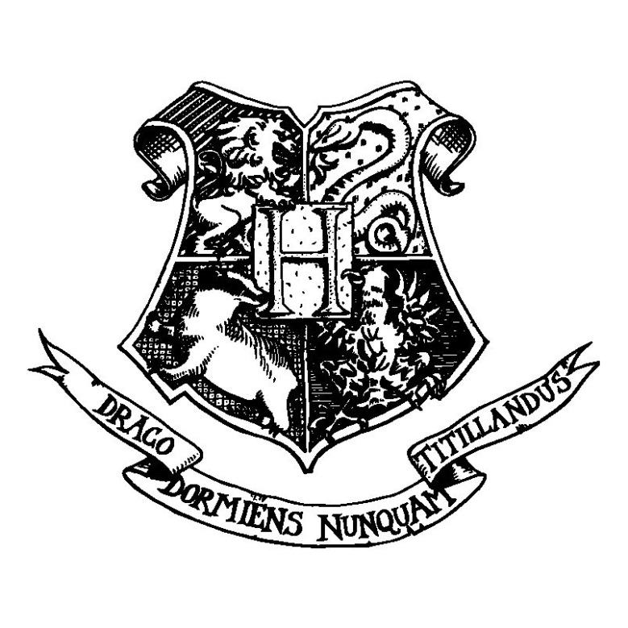
Hogwarts School
of Witchcraft and Wizardry
Headmaster: Albus Dumbledore
(Order of Merlin, First Class, Grand Sorc., Chf. Warlock,
Supreme Mugwump, International Confed. of Wizards)

Dear XXXXXX,

We are pleased to inform you that, as you have now turned eleven years of age and have the necessary talents, you have been accepted at Hogwarts School of Witchcraft and Wizardry. Please find enclosed a list of all necessary books and equipment.

Term begins on September 1. We await your confirmation owl by no later than July 31.

Yours sincerely,
Minerva McGonagall
Minerva McGonagall,
Deputy Headmistress

Hogwarts School
of Witchcraft and Wizardry

Uniform
First year students will require:
1.Three sets of plain work robes (black)
2.One plain pointed hat (black) for day wear
3.One pair of protective gloves (dragon hide or similar)
4.One winter cloak (black, silver fastenings)
Please note that all pupil's clothes should carry name tags

Course Books
All students should have a copy of each of the following:
The Standard Book of Spells (Grade 1)
by Miranda Goshawk
A History of Magic
by Bathilda Bagshot
Magical Theory
by Adalbert Waffling
A Beginner's Guide to Transfiguration
by Emeric Switch
One Thousand Magical Herbs and Fungi
by Phyllida Spore
Magical Drafts and Potions
by Arsenius Jigger
Fantastic Beasts and Where to Find Them
by Newt Scamander
The Dark Forces: A Guide to Self-Protection
by Quentin Trimble

Other Equipment
1 wand
1 cauldron (pewter, standard size 2)
1 set glass or crystal phials
1 telescope
1 set brass scales
Students may also bring and owl OR a cat OR a toad.

PARENTS ARE REMINDED THAT FIRST YEARS ARE NOT ALLOWED THEIR OWN BROOMSTICKS
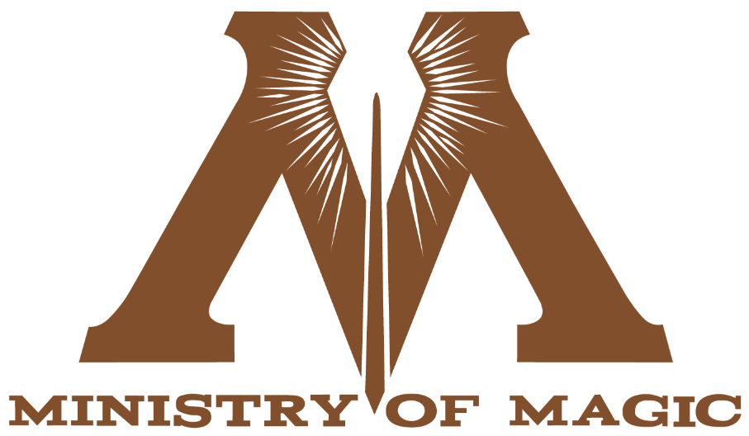

Dear XXXXX,

Due to Muggles having become recently aware of the wizarding community, the Ministry of Magic has determined that all Hogwarts letters must be sent by Muggle post until further notice.

Our regrets that your letter was not delivered by traditional owl post.

Sincerely,
Percy Weasley
Undersecretary to the Minister of Magic

